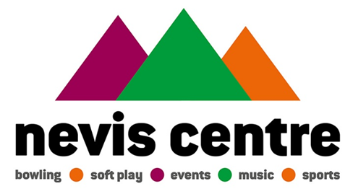
Nevis Centre Customer Card Term and Conditions

What is the Nevis Centre Customer Card?
With the Nevis Centre Customer Card, you can collect points and obtain discounts up until the 31st of May 2019!
Points
Collect points and save up to obtain a free entry to spectrum or bowling.
5 Points for every £1 you spend at peak times
10 Points for every £1 you spend at non-peak times
Discounts
The Customer Card allows you to have exclusive access to discounts!
These discounts are subject to change.
Terms and Conditions
- The Nevis Centre can cancel, withdraw or alter the scheme at any time, including these terms and conditions or any Nevis Centre account.
- All Nevis Centre Customer cards belong to The Nevis Centre.
- We do not issue additional cards for the same account.
- The Nevis Centre can take any action it considers appropriate, including removing or suspending a Customer Card account and points accrued.
- The Nevis Centre is not responsible for any liability due to loss or theft of the customer card. It is possible to apply for a new customer card if your customer card is lost or damaged.
- The Nevis Centre reserves the right to stop issuing loyalty cards at any time if we decide to terminate the Loyalty Programme
- You may cancel your customer card at any time by contacting whatson@neviscentre.co.uk
- The Nevis Centre is committed to protecting your privacy. We will always keep your personal information safe, will never sell it to third parties and will only send you marketing material if you have agreed we can do so.
- If a refund is made, we will deduct the number of points collected from your account.
- Points are not transferable to anyone else.
- Your customer card cannot be used as a credit card.
- Customers will receive a 10% discount to Spectrum and bowling up until 31st May 2019.
Collecting points
- Spectrum Soft Play
- You will collect 5 points for every £1 you spend at peak times.
- Peak times for Spectrum soft play are defined as weekends, school holidays and between 12pm-3pm on weekdays.
- You will collect 10 points for every £1 you spend at off-peak times.
- Off peak times for Spectrum soft play are defined as between 10am-12pm and 3pm-6pm weekdays.

- Bowling
- You will collect 5 points for every £1 you spend at peak times.
- Peak times for bowling are defined as weekends, school holidays and between 5pm-10pm on weekdays.
- You will collect 10 points for every £1 on off-peak times.
- Off peak times for bowling are defined as between 12pm-5pm on weekdays.

- You must spend at least £1 in a single transaction to qualify for points.
- The Nevis Centre reserve the right to alter the amount of points earned per £1 at any time.
- The Nevis Centre reserve the right to alter the value of one point at any time.
Spending points
- One point is worth 1p to spend on Spectrum admission and games of bowling.
- We will not exchange points for cash.
- Points cannot be spent on anything other than Spectrum admission and games of bowling, this includes, but is not limited to, tickets, drinks etc.
- Spending points may be subject to availability.

