The Nevis Centre
  - Event Venue information pack

About Us
Located in Fort William in the Highlands of Scotland, The Nevis Centre is a recreation centre with a multifunction hall, studio and meeting room available to let. In addition to our bowling alley and children’s soft play area, we also have a large multifunction hall that can be used for just about anything. Our studio and meeting rooms are also perfect for smaller gatherings.
We are the biggest centre in the West Highlands and if you are planning an event, meeting, conference, presentation or training days, The Nevis Centre is a customisable venue that can match your needs.

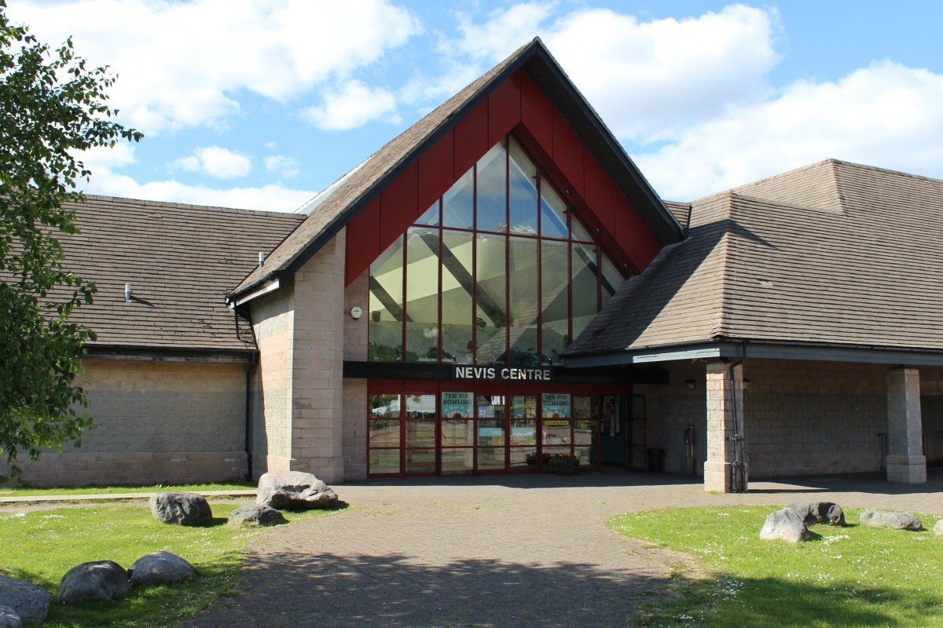

Main Hall

Our large multifunction hall has been home to music, comedy, sports, training days, presentation, parties, theatre productions, trade fairs, you name it.
It is the biggest of its kind in the West Highlands and can be dressed up or dressed down according to your needs.

Pricing
- One-off bookings for sports activities - £50.00 per hour
- Local sport group bookings - £40.00
- Local sport groups paying 4 weeks in advance - £32.00 per hour
- Day Hire – £550
All commercial event bookings will be charged on an event basis

Capacity
- Bleacher Seating: 300
- Interlocking Stackable Chairs: 200
- Standing: 700

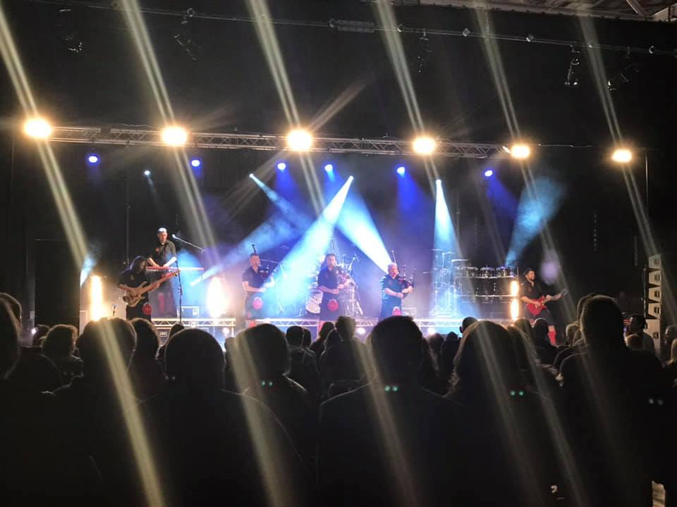
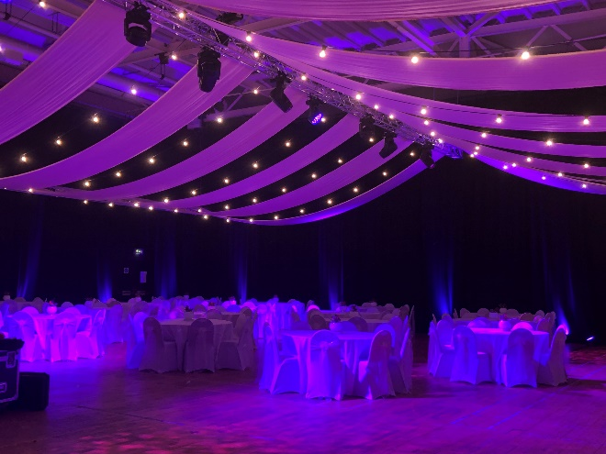
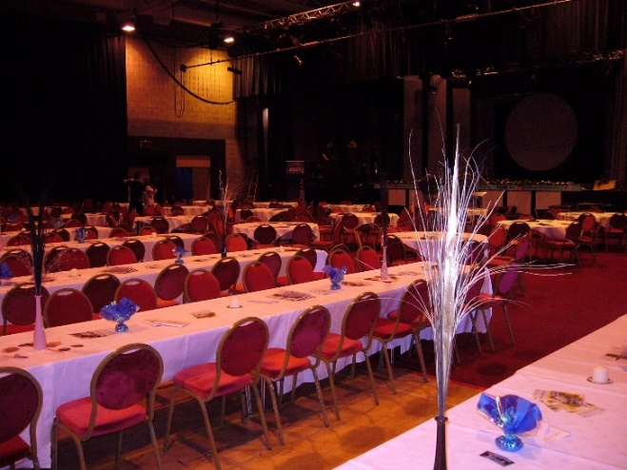
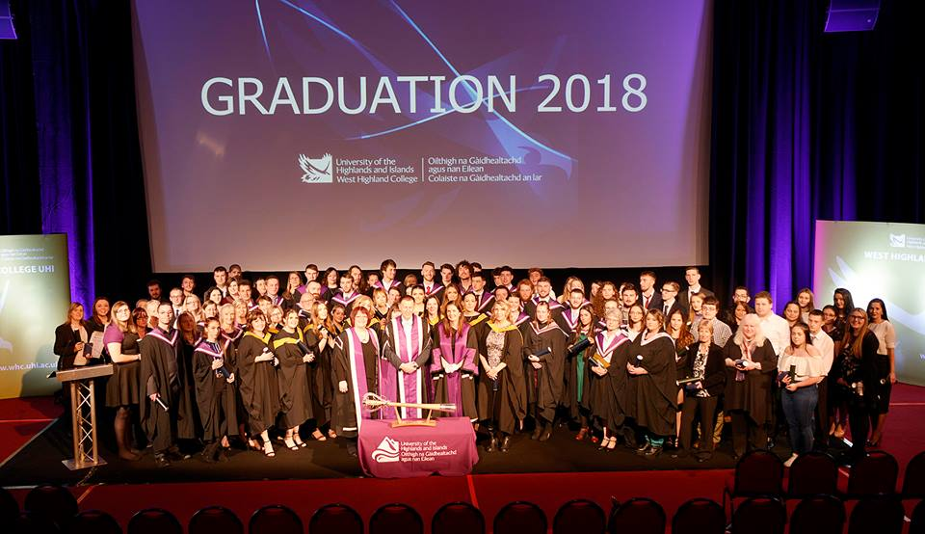
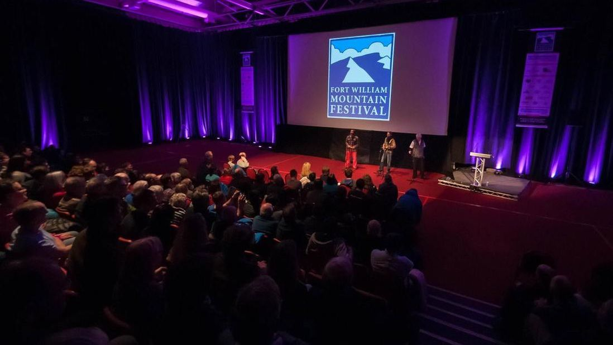
Main Hall Gallery
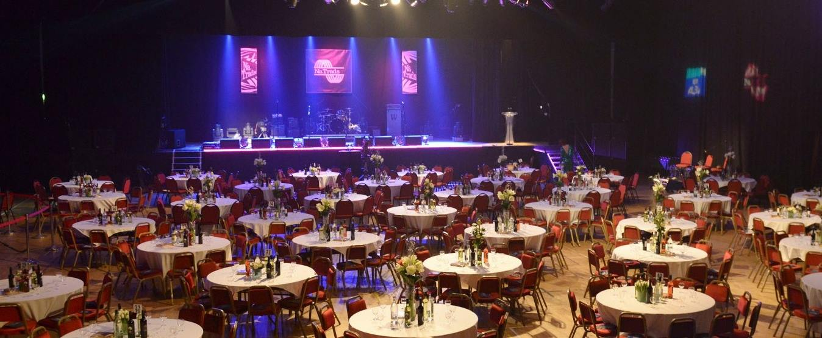
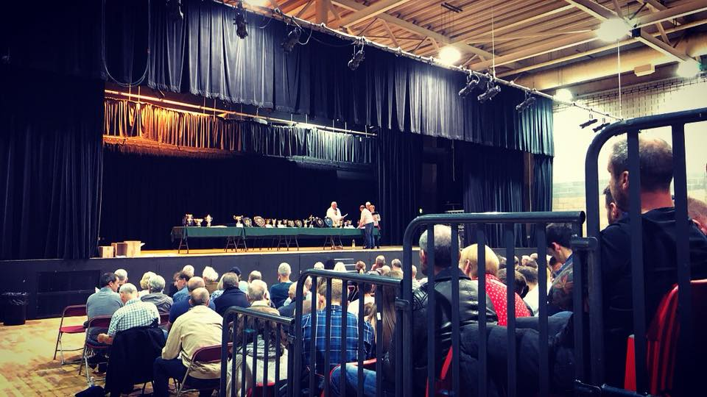

Main Hall Technical Information

Hall dimensions 35m x 24m
Stage dimensions 21m wide x 7m deep x 1.2m high
Black wool serge drapes on curtain track around the hall perimeter.
Hall can also be split in 2 with Black drapes on curtain track.
Power - 3 phase 100amp supply terminated in 125 amp 3 phase cee from socket.
1 phase 63amp supply terminated in 63amp cee form socket.
Bleacher seating for 300.
200 interlocking stackable chairs.
10 8ft x 4ft sections of litedeck with 1ft and 2ft legs.

Lighting system.
5 lighting bars on manual winches.
Lighting bar 1. 15m long 12 circuits. Max Load 100kg
Lighting bar 2. 15m long 14 circuits. Max Load 200kg
Lighting bar 3. 15m long 14 circuits. Max Load 200kg
Lighting bar 4, 15m long 12 circuits. Max Load 100kg
Lighting bar 5. 15m Long 12 sockets paired on 6 circuits. Max Load 100Kg.
Jands ESPII 24/48 channel lighting desk.
4 Strand Act 6 dimmers with 2 x 15amp sockets per channel. 15amp plug patch bay.
Pulsar 36 channel demux
Lanterns.
12 Par 64 fitted with CP62 bulbs
6 Source 4 19 deg profiles 750w
14 Source 4 Junior zoom profiles 575w
18 Source 4 Parnel 750w
12 Fresnels 650w
Portable system
1 Zero 88 12 channel Juggler desk
2 Pulsar 6 x 5amp dmx dimmer packs Twin Socapex outlets.
4 20m Socapex cables
4 Socapex – 15amp breakouts.
4 Powerdrive stands with 4 ft tee bars.
House lights.
12 1000w fresnels on 6 channel dmx dimmer controlled by main lighting desk
(Channels 25 – 30) or by separate 6 channel desk mounted in dimmer cupboard.

PA system.
Speakers 2 Logic systems ML15 – 15” + 2” 500w passive top boxs
2 Logic Systems SB1 - 18” 1000w Subs
2 Distance poles to mount tops on subs.
4 Logic Systems LM12 – 12” + 1” 400w Wedge monitors.
Control desk Allen & Heath 16 channel mix wizard with on board effects unit.
EQ Rack 2 Klark Teknik Square 1 31 band Graphics.
1 Denon CD player
Amp Rack 1 BSS Minidrive
1 QSC PLX 3102 – Top boxes
1 QSC PLX 3602 – Subs
1 QSC PLX 3102 – Wedges
Multicore 1 50m 16 channel, 8 returns Van Damme Multicore
Cables 1 10m 4 core speakon cable (Amp rack – Sub)
1 20m 4 core speakon cable (Amp rack – Sub)
2 3m 2 core speakon cable (Sub – Top box)
4 15m 2 core speakon cables (Wedges)
15 10m XLR Mic cables
5 5m XLR Mic cables
1 10m 8 way XLR stage box.
Microphones 6 Shure SM58
6 Shure SM57
2 AKG C391
8 Active DI Boxes.
10 Tall mic stands
4 Short mic stands
2 Sennheiser hand held radio mics.

Audio Visual
1 17ft x 13ft Fastfold projection screen. (Front project only)
1 Canon Xeed SX6 Data / Video Projector
1 Unicol Hanging bracket for projector
1 Denon DVD Player
1 30m VGA Cable
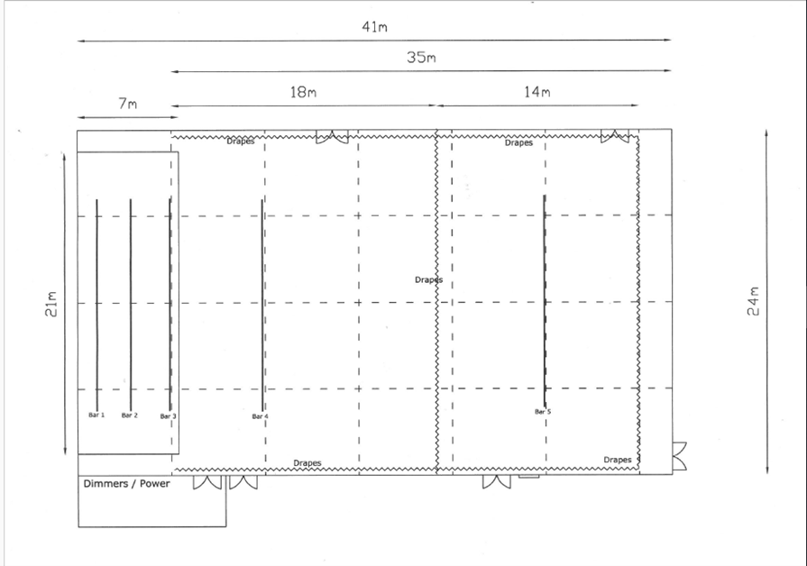
1 30m Video cable

Studio
Our Studio room is perfect for smaller gatherings, sports, training, wedding receptions, wakes, etc.
Dimensions -
9m x 13m
3.5m high

Capacity - Theatre style: 7 rows of 14 seats = 98 chairs. Giving 2-space walk isle in the middle and a walk way around the edges.

Pricing
Non-commercial booked per hour - £18.00

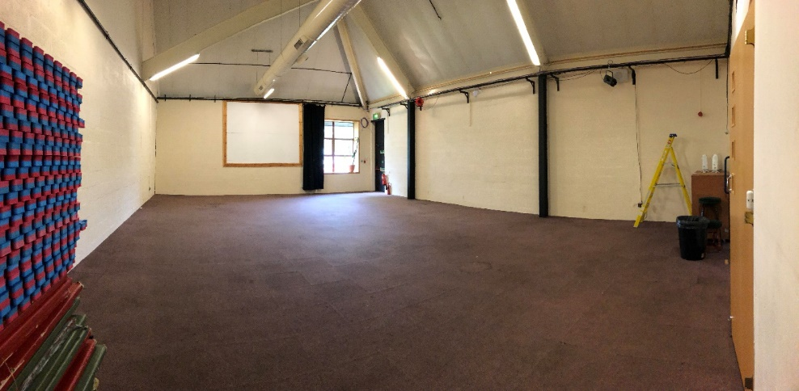

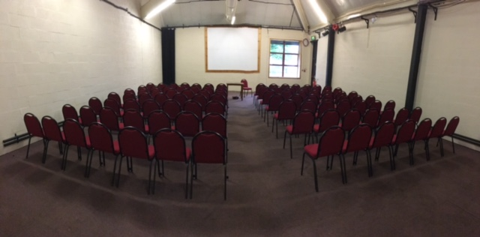

Meeting Room

Pricing
£12.50 per hour

Capacity
Board Room Style
Table Seating – 12 seats

Theatre Style
4 rows of 6 – 24 seats
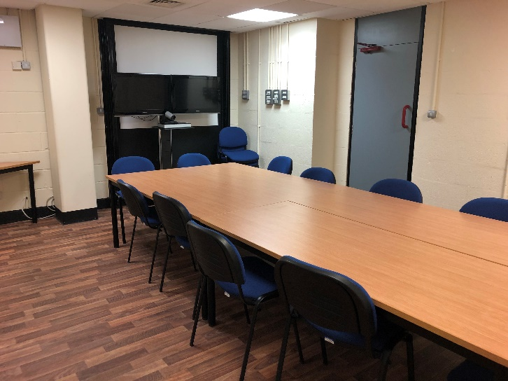

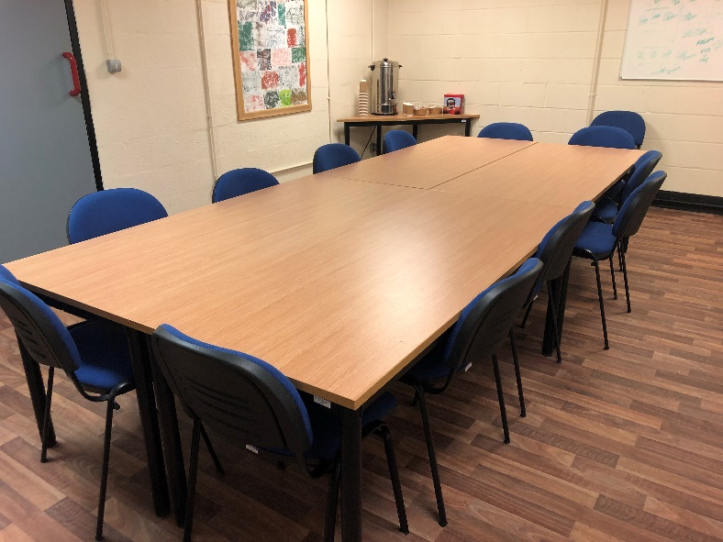
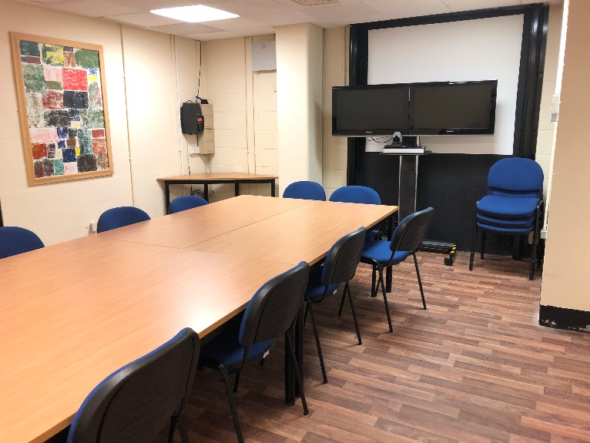

Amenities

Tickets

Ticket selling facility on our website as well as our reception box office.

Bar
Three bars in the Centre. One in our bowling alley, one in the Main Hall and one beside the Studio.
All 3 are fully stocked with spirits, whiskey, cider, beer, lager, alcopops, soft drinks, fruit juices, etc.

Catering Facilities
In house café, The Light Garden, can cater to your requirements, whether it be a light snack or larger meals.

Backstage facilities
Lady’s and men’s changing rooms, showers, toilets and 2 green rooms

Parking
Free, spacious car park that can accommodate up to 60 cars.

Internet
Strong, fast Wi-Fi connection throughout the centre with multiple direct ports.

Location

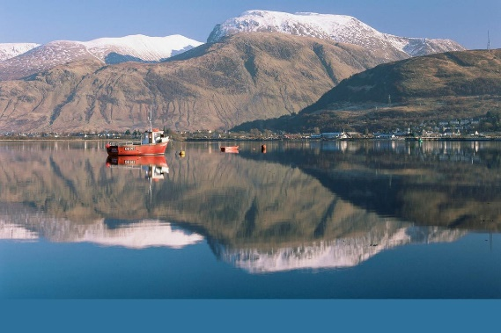
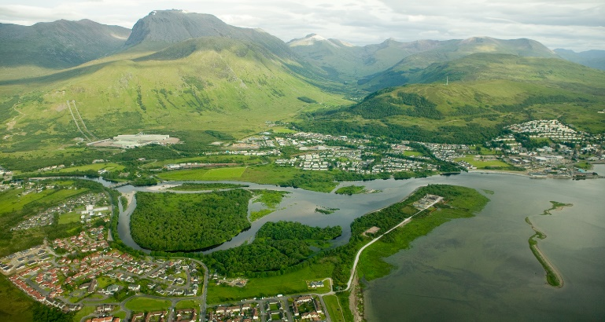
The Nevis Centre is situated in the town of Fort William. Located in the heart of the highlands, surrounded by stunning loch and mountain scenery. We are just a 5-minute walking distance of Fort William town centre with easy access to hotels, the bus station and the train station. By road, Fort William is located on the A82 which runs from Inverness to Glasgow. However, there are regular busses and trains from Glasgow, Inverness, Skye and Mallaig.
(Visit Scotland, 2018)
(Visit Fort William, 2018)

(Google Maps, 2018)

Contact

Nevis Centre
An Aird
Fort William
PH33 6AN
01397 700707

danny@neviscentre.co.uk

