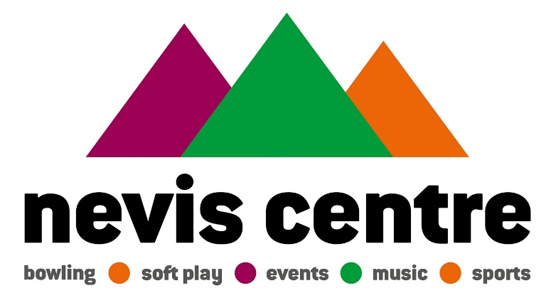
HIRE PRICES
New Prices as of 1st April 2019

Main Hall Hire
One off booking for sports activities | £50 per hour
Local sports group bookings | £40 per hour
Local sports groups paying 4 weeks in advance | £32 per hour
Day hire for large event | £660

Studio Hire
Non-commercial booked per hour | £18 per hour

Meeting Room Hire
All Bookings | £12.50 per hour

Badminton Court
1 Court | £12 per hour

All prices VAT exclusive

